St. William’s Weekly News Round 6 October 2023
No: 5
Headteacher: Miss Parker Assistant Headteacher: Mrs M Buttery
01274 545743 office@wil.bcwcat.co.uk OR message via Class Dojo

HEADTEACHER’S MESSAGE BOARD
October, the month of Mary, the Mother of God.
Mary is honoured in the Catholic Church as the mother of Jesus, the Saviour. Mary said ‘YES’ to God and we too are called to respond to God’s call in the same way. Mary is an example to us all, to gently and humbly follow God’s commandments. Your child will have the opportunity to take home a prayer bag during the month of Mary and spend some time with their family in prayer and quiet reflection. Mary, hears all our prayers and takes these to Our Lord, Jesus.

Hail Mary, full of grace, The Lord is with thee, blessed art thou among women, and blessed is the fruit of thy womb, Jesus. Holy Mary, Mother of God, pray for us sinners now and at the hour of our death. Amen.

Mary, mother of God, pray for us all.
Church News
An invitation to you and your family:
Please join us at Mass at St. William’s Church at 11am Sunday 15 October. It will be a wonderful occasion for our pupils to join St. William’s parishioners.
Pupils, wear your uniform with pride!

A huge thank you for your generosity of donated cakes and money to raise funds for MacMillan Charity last Friday at our coffee morning and community event. A huge thank you also to My Living Well, Specsavers, and West Yorkshire Police, for attending, it’s great to have strong community links where we can all work together! Our Mini Vinnies showed excellent leadership last Friday, well done! The final total is £201.87 – a fantastic amount, thank you!
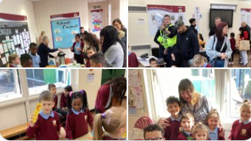
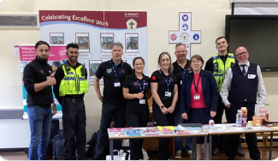
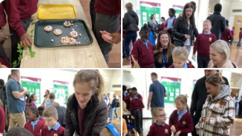
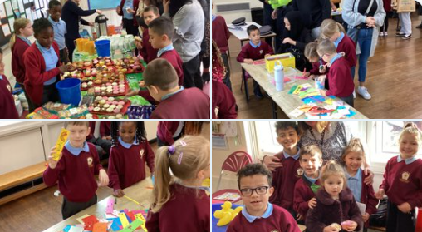
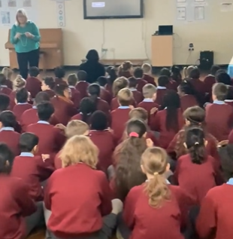
Collective Worship Assembly
On Wednesday we prayed a decade of the Rosary during our whole school Collective Worship, it was very prayerful and all of our children participated. To finish we sang Ave Maria, it was beautiful!

Oak Class
Oak class enjoyed learning how to play ‘I am in the groove’ on the glockenspiel on Monday afternoon in music.
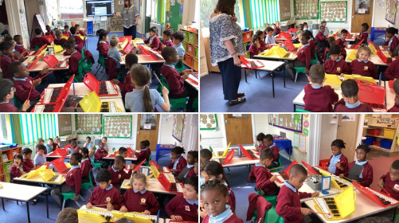
Oak class making worry dolls, from Silly Billy.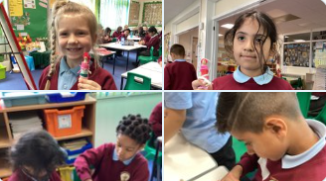
Oak class taking part in the Mark 10 mission Rosary challenge.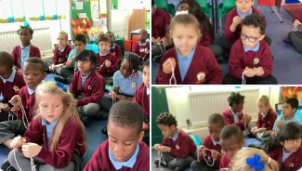
Beech Class School Mass:
Thank you Fr. Darren for celebrating Mass, on Tuesday 3 October - the children read beautifully.
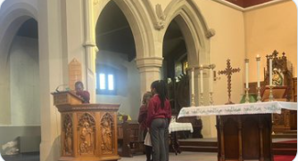
Lime Class
Children in Lime class are enjoying learning to play the Flute.
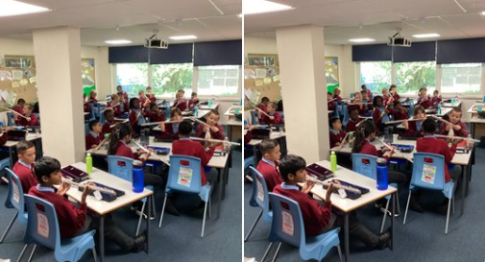
Lime Class practised using Spanish dictionaries to help them in their Spanish lesson.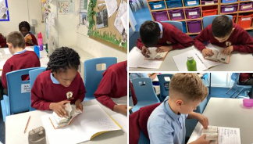

Holly Class
Another fantastic singing session with Mr Perkington last Friday, the children are sounding amazing! Well done to our singing superstars, Cassidy and Win!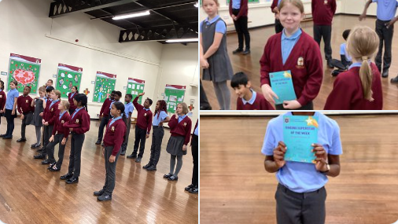
Holly Class answering comprehension questions on the first chapter of Holes.
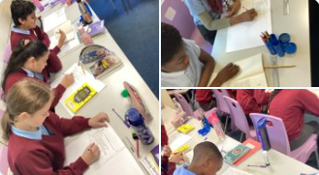
STEM – Harvest
The whole school were invited to watch STEM aka Science, Technology, Engineering and Maths – the information was relating to the processes from farming to harvesting time.
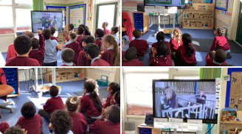

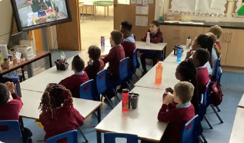

Weather
Please send your child/children prepared for our ever-changing weather conditions. Children must have a coat, preferably with a hood, everyday and suitable outdoor shoes. All children must bring a water bottle to school, this will help keep them hydrated during the day.
Please clearly mark your child(ren)’s uniform/P.E.kit with their name, this will help to eliminate lost items.

Keeping Children Safe in Education Sept 2023
All members of staff and governors complete annual safeguarding training but safeguarding children is everyone’s business and I ask all of you to make it a priority to know how to protect and safeguard your child(ren). Read Part One and Annex Five of the document https://www.gov.uk.
Contact details for parents/carers.
Please make sure that if you change your phone number you inform school staff. Following safeguarding recommendations, we need at least 2 accurate contact details in the event of an emergency; accidents do happen and there are times when we are not able to contact a parent because they have not kept us informed. Thank you.
Attendance and punctuality are a huge part of
keeping children safe and it is the law for schools to
know why and where children are if they are not in
school: schools must report children absent from school,
including parts of the day, not just absent days. As a result, systems for attendance are robust and all parents have a responsibility to inform school of their child’s absence – make sure you TELEPHONE Mrs Gadd 1st thing in the morning if your child is absent. Home visits are part of our Attendance procedures to check and do not be alarmed if safeguarding staff appear at your door. As a parent you are committing an offence if you fail to make sure that your child attends regularly. The details of parents with children who have unauthorised absence (including those who have taken unauthorised leave during term time) will be passed to Bradford Council, who could consider issuing a Penalty Notice or starting legal action. When a child meets Educational Neglect threshold then a referral to Children’s Social Care can be made.
Arriving on time is an essential life skill and for
safeguarding reasons we must lock the school gates at 8:55am – if you are arriving at that time you will have to go to the main entrance. Equally, as a school we respect parents need to collect the children from school at 3:15pm to collect other family members from other schools or colleges; we aim to be ready to hand the children to you at that time at the end of the day and not delay you.
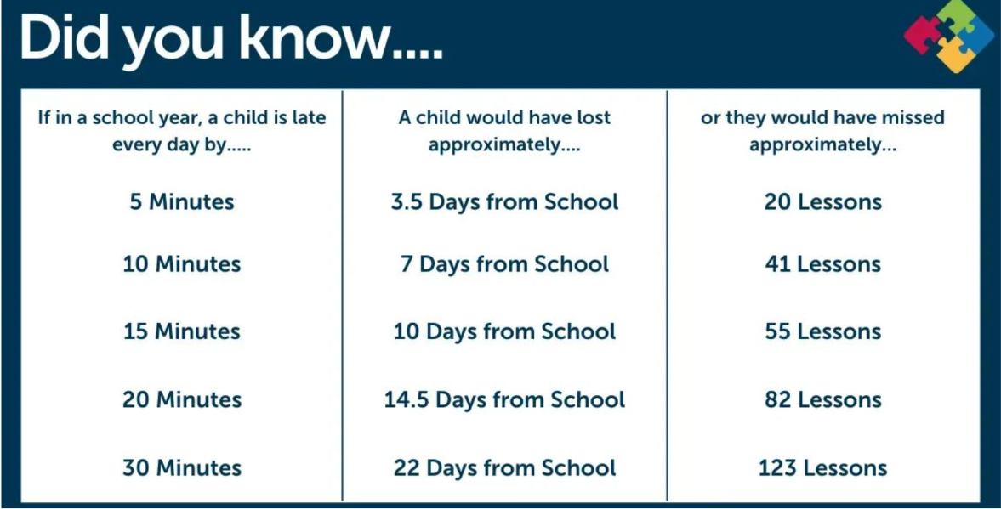
Late pick-up charges
There is a late collection charge £1, per child, for
every 5 mins you are late; sadly, some parents have been persistently late and without good reason; taking the view that it is okay for school staff to take responsibility for children after the school day. Unfortunately, we do not offer childcare after 3:15pm and many staff finish at the same time the pupils leave. Congested traffic, a late taxi, forgetting the time, having a hair colour on at the hairdressers are not acceptable reasons to be late for your child. We are understanding, if there are exceptional reasons and it is not usual for you to be late and we appreciate a phone call from you if you are going to be late, it re-assures the child as well. After school teaching staff have meetings, work to do following the school day and in preparation for the next day.
Thank you for your support with this.

Have you logged on to the National Online Safety webiste to help protect your child online? https://nationalonlinesafety.com
Parents, PLEASE monitor what child(ren) use(s) and who they have contact with online; to ensure we keep children safe and protected when they are using the internet.
Check out the tips and advice for parents to keep yourself in the know! Here are some useful websites for further information to keep children safe online:
https://www.onlinesafetyuk.com
https://learning.nspcc.org.uk
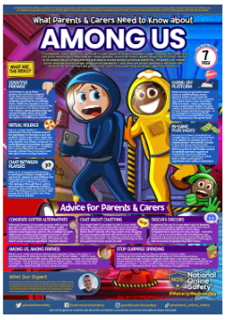
More useful websites:
https://www.thinkuknow.co.uk , https://childnet.com, https://www.internetmatters.org

Congratulations…Bravo…Well done!!!
Class teachers’ Achievement Awards: Congratulations to these fabulous award winners:
Mia, Nahom, Mario, Alexus-Marie, Claire, Riley, Danielle, Ralfs, Fredrick and Hashim.
Hot Chocolate Friday:
Janya, Ewa, Phoebe, Marcella, Oskar, Jeremiah, Eva, Amelia, Sofia and Ayra.
Virtue Certificates this week:
Aurelijus, Tymon, Harper, Fariya, Zoe, Kenny, Happiness, Bella, Win and Elise.
Golden Table Monday:
Mia, Lochlan, Karolina, Jaden and Nicola.
‘Golden Mention to our lunchtime stars’
Dexter, Michael, Gerald, Michael, Dennis, Ramina, Sebastian, Joel, Sofia and Elise.

Happy birthday to you, happy birthday to you, happy birthday dear
Connor, Prince and Fariya
Happy birthday to you!
Hope you have a special day.

Breakfast Club
Breakfast Club opens every day at 8am,
50p per child per day. A lovely way to start the day! Please arrive before 8.30am - book in advance every Friday for a place the following week via a dojo message to Mrs Gadd, Mrs Fagan, or Miss Parker!
Dates for your diary:
15/10 | Sunday Family School Mass 11am in (readers etc)
16/10 | Oak Class – Homework Projects to be handed in
16/10 | 2.50pm Ash Class Music Performance to Parents
16/10 | Beech Class - Homework Projects to be handed in
16/10 | Parent Consultation Evening
16/10 | Holly Class - Homework Projects to be handed in
17/10 | Lime Class - Homework Projects to be handed in
18/10 | Parent Consultation Evening
20/10 | School Closes at 3.15pm and Re-Opens on Tuesday 31 October 2023

P.E. Kits / Lessons
Please keep P.E. kits in school during term time, they will be sent home at the end of each term for washing.

Ash Class Monday’s,
Oak Class Friday’s
Beech Class Wednesday’s
Lime Class Thursday’s
Holly Class Friday Swimming
Lunch Menu – Week Commencing 02/10/23
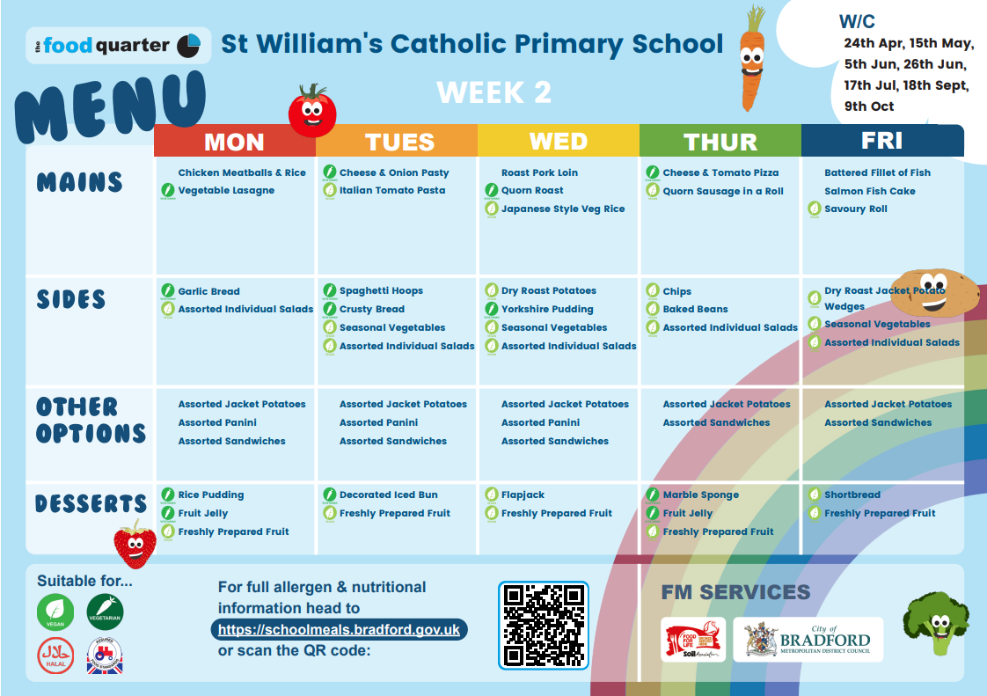
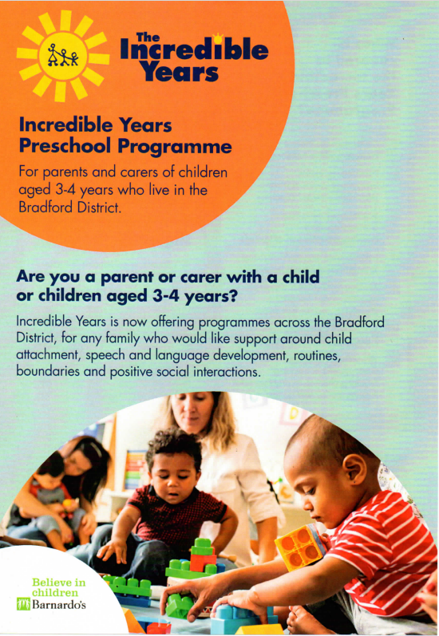
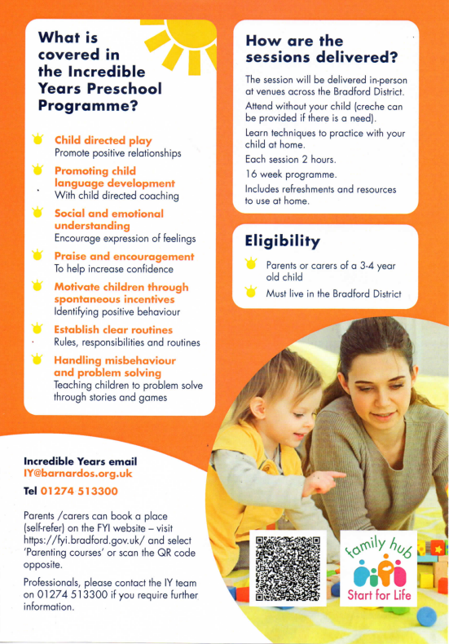
Have a lovely weekend,
See you all on
Monday 9 October 2023
at 8.45am.
Remember, it’s COOL to be in SCHOOL!

